Hancock Neighborhood Alert

_____________________________________Austin, Texas ______________________________________

CodeNEXT is the City’s proposed new land development code. The latest version is to be released very soon. It will increase density on corridors, in centers, and in neighborhoods. You may have questions about how the proposed redevelopment authorized by CodeNEXT could affect Hancock. Here are straight answers drawn from the City’s own documents. We start with the City’s proposed “transition” zones.
[Boxed quotes are from the “City Council’s Direction in Response to City Manager’s March 15, 2019 Memo re: Land Development Code Revision Policy Guidance.”]
1. What are Transition Zones or Transition Areas?
Transition Zones are neighborhood areas adjoining designated corridors and activity centers that the City is going to rezone to authorize the construction of “missing middle housing.”
“Map new Missing Middle housing in transition areas adjacent to activity centers, activity corridors, or the transit priority network”. p. 10
2. Are there Hancock streets designated as part of the transit priority network?
Yes. Duval, Red River, and 38th.
http://austin.maps.arcgis.com/apps/View/index.html?appid=3b83b4c6184343ed99eb42f22cf093c1
3. What is missing middle housing?
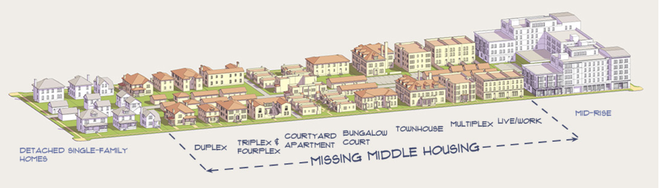
4. What level of missing middle zoning is the City going to apply to individual lots in a neighborhood transition zone?
“Four units within a house scale should be the least intense zone within a transition area, subject to staff’s consideration of what is appropriate.” (emphasis added) p. 13
5. How far do transition areas extend into neighborhoods?
“i. Generally, the transition area should be two (2) to (5) lots deep beyond the corridor lot.
ii. The depth and scale of any transition area should be set considering context sensitive factors and planning principles such as those set out in the direction for Question 4.” p. 10

Generally, “(2) to (5) lots deep” could mean ½ to 2 ½ blocks depending on the orientation of the adjoining residential blocks to the corridor (parallel v. perpendicular). The (2) to (5) lot depth, however, is a “general” rule. The Mayor (and Council majority) refused to cap it at five lots.
6. Before the City upzones homes in (or out of) transition zones, will citizens have the customary zoning notice, process and hearing with the statutory right to object through a valid petition?

The City says “no.”

7. What is the effect on the rezoned single-family homes and lots that have been upzoned?

Those homes become non-conforming uses and there will be restrictions on what can be done with the home and the land. For example, if the home is demolished, it can only be rebuilt as multifamily housing. [p. 7, 9]

8. How is parking handled in and near a transition zone – will multi-family and commercial projects have to
provide parking?

The Council instructed Staff to eliminate off-street parking requirements except in extraordinary
circumstances. And, this applies not just in the transition zones but in the first ¼ mile from a corridor.

9. Is increased density in neighborhoods limited to transition zones?

Apparently not.

“Staff will consider mapping missing middle areas in high opportunity areas not impacted by environmental concerns in order to help achieve goals related to housing throughout the city. p. 13

“High opportunity areas” are those that provide access to economic and social opportunities. The City has designated Hancock as one such area. https://www.austintexas.gov/edims/document.cfm?id=318779

10. Is the City contemplating even more housing density beyond what CodeNEXT will allow?

Yes.
Staff to provide options for timelines and methods for implementation of the new code and map and to achieve additional housing capacity and affordable housing goals beyond those contained in the new code and map.” p. 3

Furthermore, after homes in transition areas are rezoned to multi-family, there is nothing precluding a developer (and then another) from purchasing the sixth (seventh, eight, etc.) lot from the corridor or other homes on the block and requesting multi-family zoning using the CodeNEXT zoning as a precedent.

11. What is the overall housing goal for the City and where does the City plan to put that housing in addition to corridors, centers, and transition zones?

The CodeNEXT housing goal for the City is to create the capacity for 405,000 new units by through rezoning.

“The new code and map should allow for housing capacity equivalent to at least ​ three ​ times the Austin Strategic Housing Blueprint (ASHB) goal of 135,000 new housing units.” p. 5

The Council instructed Staff to map a great majority of this new housing capacity within ½ mile of corridors and centers. As noted, Staff was told to consider, as well, high opportunity areas.

75% of new housing capacity should be within ½ mile of transit priority networks as identified by the Austin Strategic Mobility Plan and Imagine Austin activity centers and corridors. Staff should update the growth maps for Imagine Austin including both corridors and centers. p. 9
“Staff will consider mapping missing middle areas in high opportunity areas not impacted by environmental concerns in order to help achieve goals related to housing throughout the city. p.13
12. Are there other concerns with the Council direction to Staff?

Yes. There are concerns across the City 1) that the direction Council has given to Staff will actually work against affordable housing, and could risk displacement of homeowners and renters through redevelopment and higher property taxes; 2) that redevelopment maximizing the impervious cover entitlement could exacerbate flooding and drainage problems and potentially reduce the tree canopy in some areas; 3) with the relaxation and in some cases the elimination, of compatibility standards (especially as they apply to commercial development); 4) with the encroachment of incompatible commercial uses, and 5) with the potential elimination of some protective conditional overlays that mitigated the impact of higher intensity zoning. An examination of these concerns (and it is not an exhaustive list) is an important discussion outside the scope of this article.

ACTION ITEMS:

If you are concerned about the City’s plans, don’t wait to speak up – things are moving fast. Write to the Mayor steve.adler@austintexas.gov and Councilmember Kathie Tovo kathie.tovo@austintexas.gov Tell them that you do not agree with the City Council’s direction to Staff and, further, that we want a process that respects our right to have a meaningful say in the future of our homes and our neighborhood.

Thank you.

